# **Research & Development**

# **Tasks of construction**

* Creating and maintaining of construction drawings with SolidWorks and CatiaV5
* Construction of surgical instruments and appliance for production
* Project coordination of production drawings
* Prototype construction with the 3D printer
* Active involvement in already existing projects
* Project documentation

# **Tasks of risk management**

* 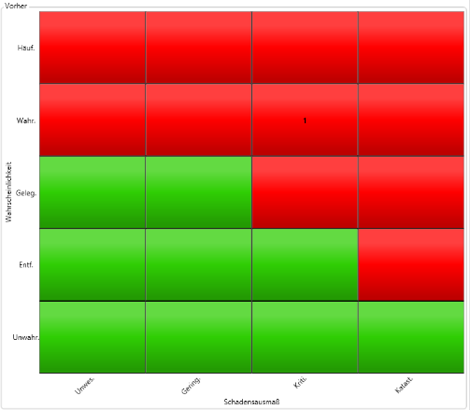Valedating and finishing measures
* Participation in meetings
* Updating the meeting protocol

1

* Working with Qware® Risk manager

# **Results**

* 5 of 14 development projects could be concluded
* Created about 200 construction drawings
* 109 measures were validated
* The master risk analyses were concluded

# **Personal conclusion**

The internship at the company LAWTON

was great. I have gained a lot of practical

experience which will help me during the

studies and later in the job. Most

interesting for me was the construction

of 3D models and working with the 3D

printer.